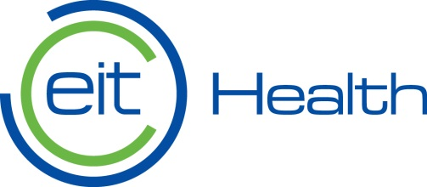

EIT Health is one of the world's leading initiatives promoting sustainable health care. Promoting healthy living conditions, active aging, and improving the well-being of people across Europe are key objectives of the organization. The initiative brings together over 135 partners: top research institutes, universities, clinical hospitals, diagnostic centers, medical equipment manufacturers and corporations from across Europe such as GE Healthcare, Karolinska Institutet, Oxford University, Heidelberg, Roche, Siemens, Philips.

How does EIT Health work?
The consortium finances and implements projects in three areas: Accelerator supports innovation at the level of commercialization of research and access to foreign markets; Campus is committed to education and provides professionals with the conditions for entrepreneurship development, eg through high quality training programs; Innovation is focused on interdisciplinary activities devoted to the diverse needs of healthcare in European countries.

PROJECTS 2017

Smart-up Lab
An innovative, interdisciplinary training program aimed at developing knowledge and practical skills in the area of innovation and entrepreneurship.

FOR WHOM?
Open for all

WHEN:
01.01.2017 – 31.12.2017

PROJECT VALUE:
358 596,00zł

More: http://eithealth.pl/pl/2017/01/09/smart-up-lab/

Local Training Network
Support and creation of an European network of startups in the field of health innovation.

FOR WHOM?
Start-ups from the field of medicine, healthy lifestyle

WHEN:
01.01.2017 – 31.12.2017

PROJECT VALUE:
67 200,00zł

More: https://www.eithealth.eu/en_US/accelerator/incubate/i-ntegrate

InnoStars Awards
Competition for European healthcare entrepreneurs in the early stages of development. Customize and develop concepts to start
a business or create a start-up.

FOR WHOM?
Startups or individuals who own a prototype but have no customers

WHEN:
01.04.2017 – 31.12.2017

PROJECT VALUE:
21 000,00zł

More: http://www.innostarsaccelerator.eithealth.eu/innostars-awards/

European Health Catapult 2017
Competition for market-oriented health care companies. Support to transfer products and services to another EU market.

FOR WHOM?
SMEs, start-ups and other companies having a product and customers
WHEN:
01.04.2017 – 31.12.2017

PROJECT VALUE:
21 000,00zł

More: http://www.innostarsaccelerator.eithealth.eu/health-catapult/

